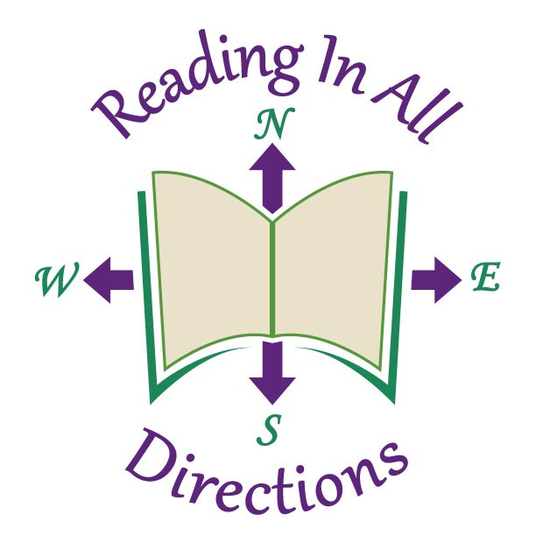

Dear West Virginia Authors,

The West Virginia Reading Association is delighted to offer, once again, a special $40.00 registration rate for the 2017 conference, Reading in ALL Directioins at the Greenbrier Resort in White Sulphur Springs on November 16 and 17, 2017. The rate is $60.00 off the regular preregistration rate.

Please complete and return the registration form specially designed for you on or before October 16, 2017. With this rate you will receive space at a tale in the Author Interactive area currently slated to occur in the Exhibit Hall. We have listened to he Author’s feedback requesting to be a part of the Exhibit Hall.

If you wish to purchase a ticket to one of the special luncheons, indicate your choice on the attached form. These are also $45.00 each. Kindly include payment.

Please indicate below, the times you will be at the conference. This will allow the conference committee chair to make sure there are enough tables available for all authors.

If you prefer to be in the exhibit area, those applications are online at wvreading.com and are available for $250.00 per table.

While at your table, you may sell and sign as many books as you wish. Please note that all materials should fit on a standard size table and should not interfere with other authors who are present.

Attendees enjoy visiting with authors during the conference and we hope that this will enable you to network with conferees and other authors. We look forward to seeing you in November.

Times YOU will be Present
Thursday:_________________________________________________________________
Friday:___________________________________________________________________

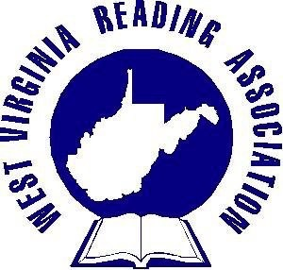
Lodging is the responsibility of the author. A special rate is available from the Greenbrier. The form may be obtained at wvreading.com. under Conference 2017.

Kind regards,
Jefferson County Reading Council
c/o AlyvceAne Moore
PO Box 112
Shenandoah Junction, WV 25442

